ESC and SegFault

Shourya Khare

Ujjawal

Pawan Chanukya

Himanshu

Pavi

Karunaya Garg

SolveForIITK

Students’ Gymkhana Recruitment Portal

**Target Problem:**

In the preceding month, we have received more than a dozen mails from various student bodies regarding recruitment. Keeping track of separate applications to so many cells, societies and clubs has become difficult. There are different deadlines to apply and different deadlines to submit recruitment tasks; this may lead to students missing their deadlines.

**Proposed Solution:**

We would like to take inspiration from the SPO website and develop a common recruitment portal to be hosted on the Students’ Gymkhana website. This portal shall depict in an organised manner the status of recruitment of all cells and clubs.

The website will showcase all deadlines and will provide links to application forms and recruitment task submission forms. The website will also accommodate any circulars/announcements relating to the recruitment processes.

The coordinators of respective bodies will be able to email the links of their google forms which shall be promptly updated on the website in the form of a button.

This is a very lightweight solution as it is a static website and can be easily hosted on google sites / github pages if the need arises (any issue with the students.iitk.ac.in domain).

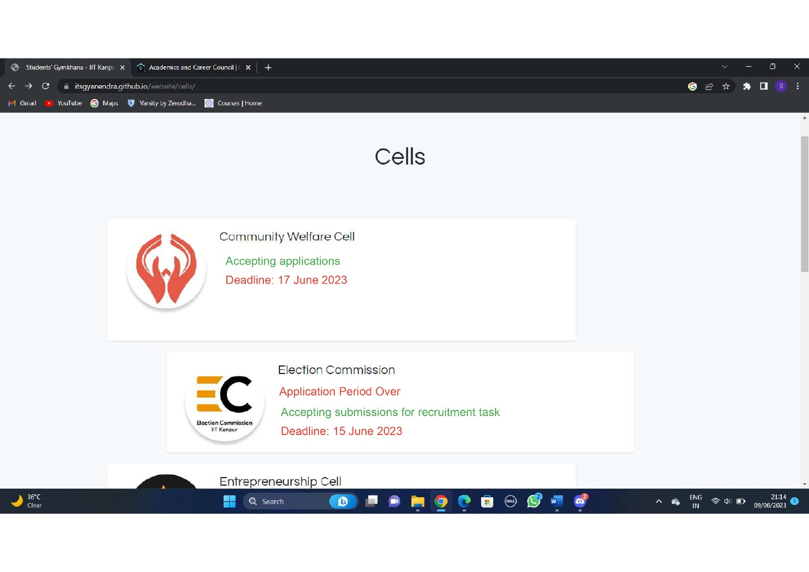

*Pictorial depiction of the planned website*

**Long term plans:**

We will be eager to improve this website in the future and transform it into a dynamic website with forms embedded into the website.

Such a website will require a login facility and hence a server. Embedded forms imply that coordinators will be able to decide the design of the form. To accommodate this, we look forward to also creating an interface where coordinators of student bodies will be able to design recruitment forms as per their needs and push then directly to the website.

Such an interface will make it possible for a coordinator to push forms to the site without the use of GitHub.